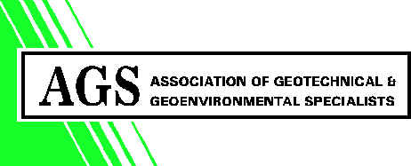
Forum Court
83 Copers Cope Road
Beckenham
Kent BR3 1NR. UK

Tel: +44 (0)20 8658 8212
Fax: +44 (0)20 8663 0949
e-mail: ags@ags.org.uk
website:www.ags.org.uk

AGS Legal Helpline

Berrymans Lace Mawer have offered to provide a legal helpline to AGS Members on the following terms:

- Up to 20 minutes of free telephone advice.
- Berrymans Lace Mawer will not be liable for the advice given.
- Berrymans Lace Mawer will not receive payment for the telephone advice service.
- The service will be completely confidential.

Berrymans Lace Mawer are willing to are willing to be formally appointed on appropriate terms should the complexity of the issue require their engagement after the expiry of the 20 minutes free advice period,

Areas of legal practice likely to be relevant to AGS members:

- General legal advice on geotechnical/geo-environmental matters
- Contract drafting and advice on Appointments
- Collateral warranties and bonds.
- Copyright
- Dispute resolution including arbitration, adjudication and mediation as well as court procedure etc.
- Environmental Law
- Health and Safety and Environmental prosecutions
- Employment Law

020 7638 2811

Users should quote the ‘AGS legal advice line’
and ask for Michael Salau, Guy Lane or Zita Mansi

